7.0 TESTING
7.1 Testing Plan
The aim of the testing process is to identify all defects existing in software Product. However for most practical systems, even after satisfactorily carrying out the testing phase, it is not possible to guarantee that the software is error free. This is because of the fact that the input data domain of most software products is very large. It is not practical to test the software exhaustively with respect to each value that the input data may assume. Even with this practical limitation of the testing process, the importance of testing should not be underestimated. It must be remembered that testing does expose many defects existing in a Software product. Thus testing provides a practical way of reducing defects in a System and increasing the users’ confidence in a developed system.
Functional Testing: The testing technique that is going to be used in the project is black box testing. In black box testing the expected inputs to the system are applied and only the outputs are checked.
The working or the other parameters of the functionality are not reviewed or tested on the black box testing technique. There is a specific set of inputs for each and every module which is applied and for each set of inputs the result or the output is verified and if found as per the system working this testing is termed or result is declared as pass.
If the set of inputs that are provided to each module are not giving the outputs as per the expected results from the module then the result of that testing is to be declare failed.
Moreover the bottom up integration of the modules is applied herein so that each module can be verified at the initial stage and if it is found that the independent module is perfectly alright, only then it is going to be integrated with other related modules otherwise the module is checked for flaws and then if it satisfies all the specific requirements of the module, is integrated to other related modules to form and incorporate a system.
In the black-box testing approach, test cases are designed using only the functional specification of the software, i.e. without any knowledge of the internal structure of the software. For this reason, black-box testing is known as functional testing.
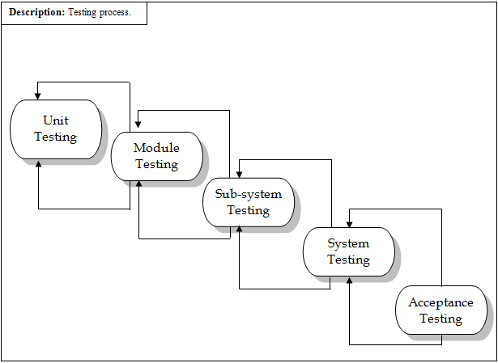
Fig: 7.1 Testing Process.

7.2 TESTING STRATEGIES
The black box testing is going to be used for the project. The entire module is going to be checked for the specific inputs and the output is going to be checked. We are going to test the modules individually and thereafter if found to be working as per the expectations they are going to be integrated with other successfully tested modules and then on integrated.
At last all the modules are integrated and thereafter it is checked on a broader basis and all the requirements which are specified are checked for each integrated system modules. If all the functionalities are successfully satisfied than the entire integrated system is found to be working perfectly alright.
The integration is going to be in a bottom up manner where in each individual modules are going to be checked for the first time initially. Later on as and when other modules are developed and are in a working condition than they are integrated and the entire system is going to be generated. As mentioned before these entire system will finally be tested as per the requirements specified by the customer if any flaws are seen they are immediately required to be solved. In short the entire system should be working as per the requirements with no unexpected results.

7.3 TESTING METHODS
Involves execution and implementation of the software with test data and examining the outputs of the software and its operational behavior to check that it is performing as required.

7.4 TEST CASES
Test Case ID | Test Case | Expected Result | Actual Result
TCS1 | Check all links to other pages. | It should call the concerned page | APE
TCS2 | Verify validations | It should prompt user for valid inputs | APE
TCS3 | Check whether user Interface is according to requirement or not | User should be required to give less input and have detailed output | APE
TCS4 | Confirm whether the Administrator is given all the control over the system or not | Admin should have full control over the system | APE
TCS5 | Make sure output is coming as per given input or not | Output must be correct with respect to Input | APE
TCS6 | Try out response time of each request | Requested page should not take much time to be load | APE
TCS7 | Check out browsers compatibility with different resolution | It should work proper in Mozilla, IE other browsers with different resolution | APE
TCS8 | Check out whether the user is given facilities of system according to his/her role | Admin should have more facility of the system compare to normal user | APE

